Summary of analysis

2003 average JJA temperature 17.3

2011 average JJA temperature 14.8

Chalk and slope

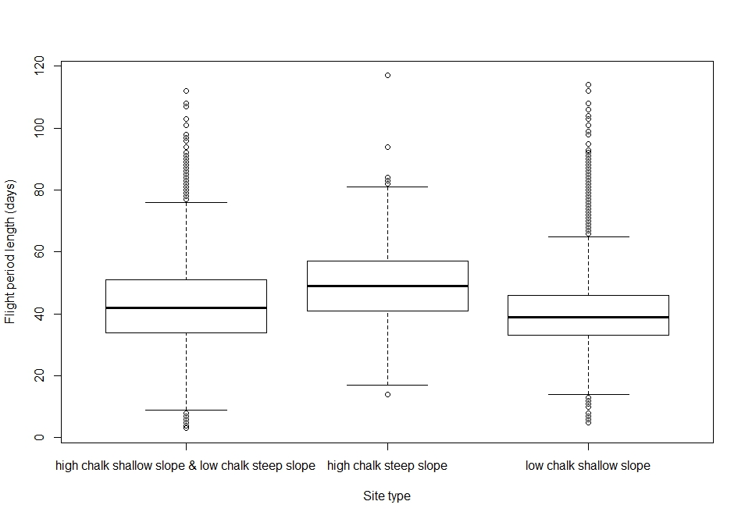Flight period length

Flight period is longest on high percentage chalk sites with steep slopes (49.3 days) and shortest on low chalk percentage, shallow slopes (41.0 days).

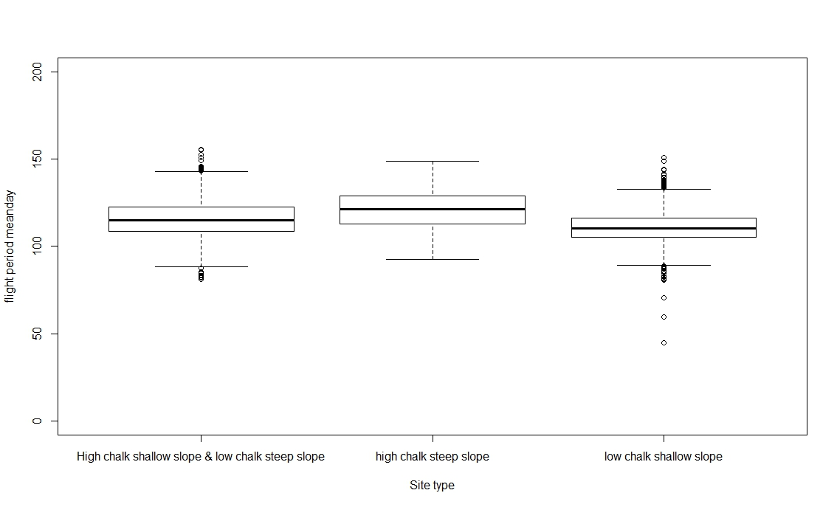Mean flight day

Mean flight day is latest on high chalk steep slopes (day 121.3) and earliest on low chalk, shallow slopes (day 110.9).

Flight period start days

High chalk % steep slopes start later in the flight season compared to other site types.

|  |  |
| --- | --- |
| Site type | Mean flight period start day |
| low chalk shallow slope | 87.43 |
| High chalk shallow slope & low chalk steep slope | 91.08 |
| high chalk steep slope | 93.10 |

Flight period end days

High chalk % steep slopes finish later in the flight season compared to other site types.

|  |  |
| --- | --- |
| Site type | Mean flight period end day |
| low chalk shallow slope | 128.44 |
| High chalk shallow slope & low chalk steep slope | 135.06 |
| high chalk steep slope | 142.43 |

Chalk sites vs Latitude

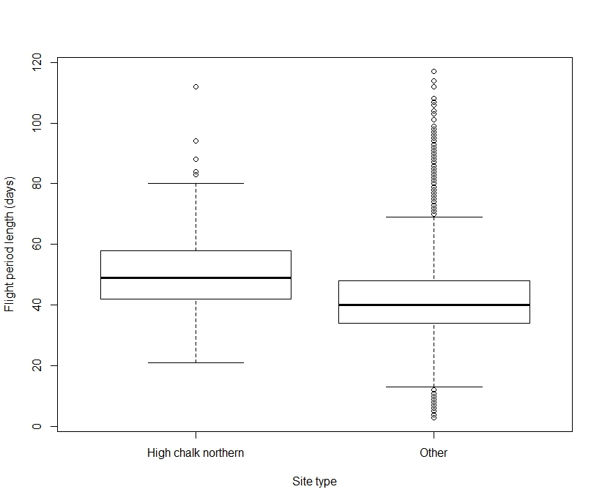Flight period is longest on northern high chalk sites (50.7 days) compared to all others (42.09 days).

Mean flight date is latest on high chalk northern sites.

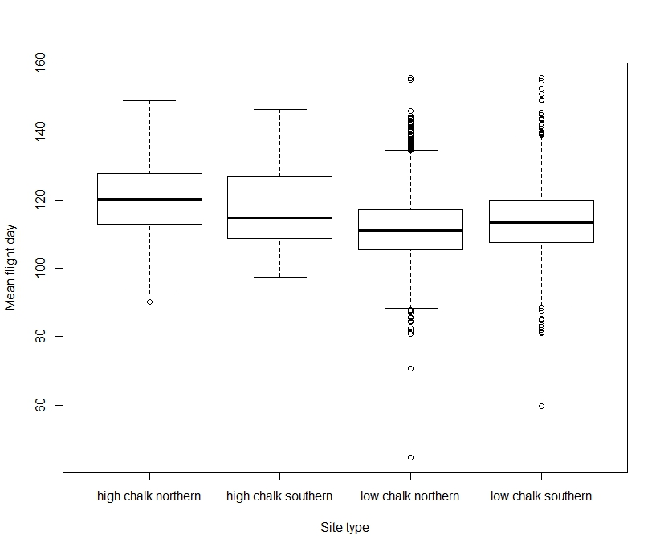

|  |  |
| --- | --- |
| Site type | Flight period mean day |
| low chalk northern | 111.67 |
| low chalk southern | 114.00 |
| high chalk southern | 117.97 |
| high chalk northern | 120.37 |

Flight period starts earliest on low chalk northern sites (87.60) and latest on high chalk southern sites (93.04)

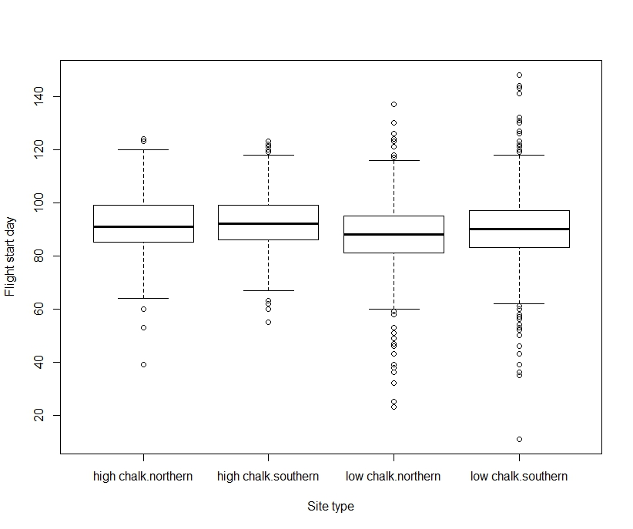

|  |  |
| --- | --- |
| Site type | Flight period start day |
| low chalk northern | 87.60 |
| low chalk southern | 90.22 |
| high chalk southern | 93.04 |
| high chalk northern | 91.74 |

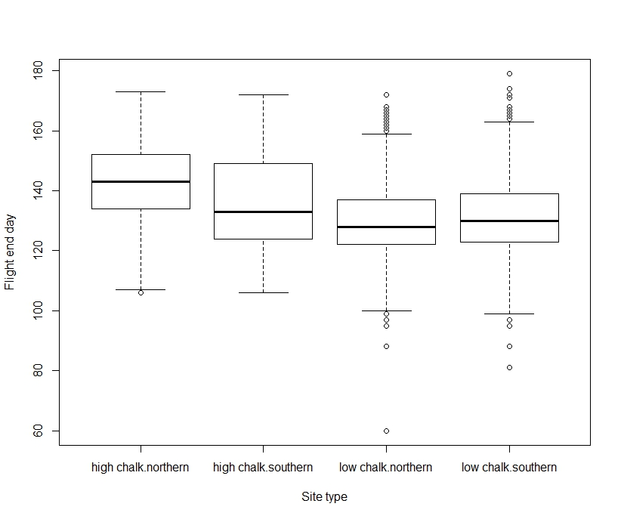Flight period ends earliest on low chalk northern sites (129.70) and latest on high chalk northern sites (142.47).

|  |  |
| --- | --- |
| Site type | Flight period start day |
| low chalk northern | 129.71 |
| low chalk southern | 131.97 |
| high chalk southern | 136.22 |
| high chalk northern | 142.47 |

Individual variables Flight period range Mean

Chalk

High 47.51 119.35

Low 41.96 112.63

Latitude

Northern 43.92 113.51

Southern 42.10 114.89

Slope angle

Steep 45.86 118.00

Shallow 41.39 111.49

Slope facing

North 42.61 113.71

South 43.66 114.47

East/West 42.45 109.71

No sig dif between slope facing results for mean or range.